一、The Link-Up button is shown below:
2.1Bluetooth connection is opened
APP is shown below：
Tip whether to open the Bluetooth selection: Allow

2.2 The following figure appears after the Bluetooth message is opened：

2.3Clicking the “Bluetooth Scan”button will display the scanned Bluetooth name：“FEASYCOM”Click on the name to connect successfully
As below show：

三、The“Tag” button is shown below：

3.1 EPC Button are identified in the figure below：
The identified tag number displayed as the "24-bit EPC number" displays the total number of reads and the number of tag identified。
Click

3.2 EPC+TIDIt will be identified simultaneously
“EPC+TID”The label numbers of the two regions are shown below：
You can clear the tag number identified on the screen，Tx and Rx Is the data receiving and sending state.
Long press：

四、The “Access” button is shown below：

To write about the label number: E211 3343 5565 7789 9722 1133, select the label number to be written，
The label number that needs to be written will be automatically selected and automatically switched to the "Access" interface as shown in the figure below：
4.1 Access is mainly based on the label read / write function operation
With the label number: E211 3343 5565 7789 9722 1133, such as the following figure：

After automatically switching over the "Access" interface, the status is displayed: display the selected tag number, click the "Access" button, and the data box shows the selected tag number
The label number of is shown below：

Address filling: 2 Length filling: 6，Can operate the whole EPC 24 bytes。（Note：TID is read-only and cannot write）
The Write operation selects the selected label number：
，Select the area to write, take the EPC area, for example，
The operation was successful as shown in the figure below：

Tip: Select the "Label" button after successful writing to read the tag number just being written. If you write fails, prompt " Write fails”。
Write was successful, read the following below：

Before Written number: E211 3343 5565 7789 9722 1133,
after written number: E211 3343 5565 7789 9722 6666
Other area read and write operation is the same as the above.

EPC area read: Address: 2 Length: 6
TID read：Address：0 Length：6
Note：User field longest read: Address: 0 Length: 32
Password field：Address: 0 Length: 4

五、The Configure button is the figure below：

1."Automatic connection" is closed by default, this function is to open the Bluetooth APP and click "Bluetooth scan" to automatically connect the device.
2.Bluetooth Reader is the default device and Bluetooth handheld for other devices (optional)。
3."Detection sound" is the sound detected by the APP start。"Bezzer on" / "Bezzer off" is for Bluetooth readerThe buzzer prompt (on / off) saves the current state。
4."Auto read on / off" is to automatically read the card, no need to connect to DEMO or Bluetooth, can be open or off。
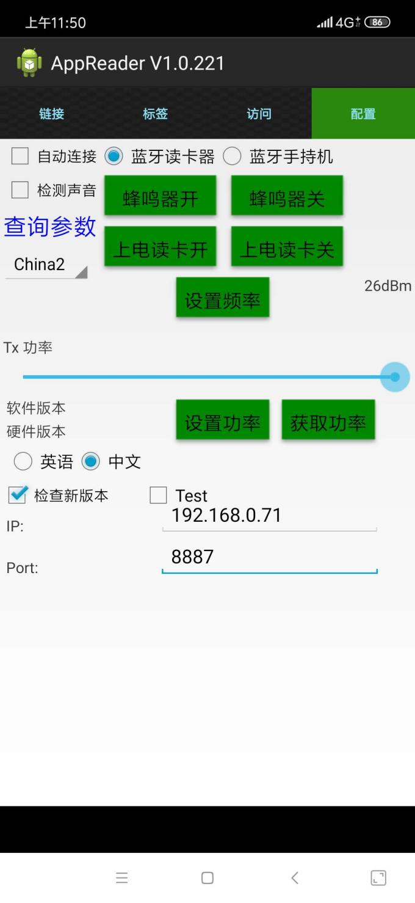

5.1Query parameters：
1.”Set Frequency” selects another country / region band range。
2."Set Power" sets the RF power of the Bluetooth reader (sliding dot adjustable tag identification distance)，Choose to adapt
After the power value, click "Set Power".
3. "Get power" is to obtain the current RF power status value of the Bluetooth card reader.(Note: The above settings will save the current situation
price)

